Project Proposal

Project Name: Boardroom booking system

Prepared By:

John McMullin

Table of Contents

Introduction 3

Architecture 4

Data Aspect 4

Function Aspect 4

Network Aspect 5

People Aspect 5

Timing Aspect 5

Motivation Aspect 5

Project Plan 5

# Introduction

The purpose of the Boardroom booking system is to allow companies, groups, or a people to book boardrooms at different buildings located across Canada. The system is comprised of two websites, a database server (MySQL), and a web server (Apache TOMCAT). The main site is for external users (normal users) and the second site is the administrative site for the internal users (admin users). The main site will provide the following features:

* Creating an account with the system’s login
* Browse boardrooms in different provinces and cities
* Browse boardrooms based on user requirements (i.e. Total space/number of people allowed)
* Book a boardroom with an account
* Allow language change between English and French

The administrative site will provide the following features:

* Administrative access
* Creation of new admin user accounts
* Add new buildings
* Add new rooms to a building
* Editing existing buildings and room information
* Allow language change between English and French

This system will be developed by the following people:

* Andrew Hart
* Matt Pucci
* Steve Fougere
* Pat Rowlee
* John McMullin

# Architecture

## Data Aspect

**Board Room Booking Database Map Version 0.1**

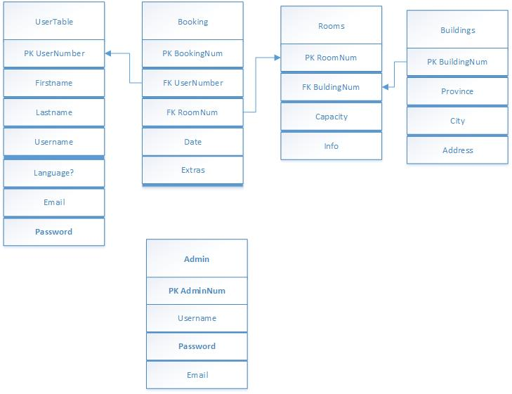

## Function Aspect

|  |  |  |
| --- | --- | --- |
| Function # | Description | Users |
| FM1 | Allow users to create account with the system and log in with those accounts | Non-account user/account user |
| FM2 | Allow user to see, update, and delete their account information | Account user |
| FM3 | Switch the language of the site between English and French and remember the user preferred setting. | Non-account user/account user |
| FM4 | Allow user to browse through a list of all boardrooms | Non-account user/account user |
| FM5 | Allow user to filter the list of boardrooms based on different criteria and have the list auto-update based on the filter criteria:   * Province/city * Building * Room size | Non-account user/account user |
| FM6 | When a room is selected show the user more info on the room   * Building with full address * Province/city * Room size * Room description | Non-account user/account user |
| FM7 | If the user is logged in allow them to book the room by letting them chose the date and time to book. Then have them confirm that choice. | Account user |
| FM8 | Allow the user to see all rooms that they have booked (past and future) | Account user |
| FM9 | Select the closest building to the user location |  |
| FA1 | Access to the site by admin account only | Admin user |
| FA2 | Switch the language content of the site between English and French and remember the user preferred settings | Admin user |
| FA3 | Allow admin user to create more admin accounts | Admin user |
| FA4 | Allow admin user to add new building to the system | Admin user |
| FA5 | Allow admin user to add new rooms to existing building in the system | Admin user |
| FA6 | Allow admin user to update info on existing buildings in the system | Admin user |
| FA7 | Allow admin user to update info on existing rooms in the system | Admin user |
| FA8 | Allow admin user to delete or disable existing building and perform the same operation all rooms within that building | Admin user |
| FA9 | Allow admin user to delete or disable existing rooms | Admin user |

## Network Aspect

Diagram showing the structure of the system (web browser, tomcat server, database server?)

The web server and database server are all located in the main building which is located in Ottawa, ON Canada. With user access the site from all over Canada.

## People Aspect

There are three types of users that will be using the system, a non-account user, an account user, and an admin user. The non-account user is a guest account that allows them to view boardrooms or create an account. The account user are the ones that have created an account with the system and are able to browse and book a room. The admin account are the only users that can access the admin site to make changes and updates to the system.

## Timing Aspect

Our most crucial component to complete first is the database. The database lays out the foundation of our system and how our features will be structured. Having a database which is normalized and contains no redundant data will ensure our features are built correctly and efficiently.

## Motivation Aspect

Create a booking system which is easy to use and is efficient. Create a stable system to prevent double or lost bookings. Maintain a high level security to prevent sharing of personal information without consent.

# Project Plan

**Board Room Booking Feature Release Plan 0.1**

|  |  |  |  |
| --- | --- | --- | --- |
| FUNCTION | DESCRIPTION | RELEASE (FEB 1st) | PROJECT MEMBERS |
| FM1 | Skeleton Homepage (Basic Design) | 0.1 | Andrew Hart |
| FM1 | Register Form (Account Creation) | 0.1 | Matt Pucci |
| FM1 | Login Queries (Connect to Database) | 0.1 | Steve Fougere |
| ALL | Create Database (MySQL) | 0.1 | Pat Rowlee |
| PAPERWORK | Documentation & Proposal | 0.1 | John McMullin |